**Vel Tech Rangarajan Dr. Sagunthala R&D Institute of Science and Technology**

 **(Deemed to be University Estd. u/s 3 of UGC Act, 1956)**

**School of Computing**

**B.Tech. – Computer Science and Engineering**

**VTR UGE2021- (CBCS)**

Academic Year: 2025–2026

SUMMER SEMESTER - SS2526

Course Code : 10211CS207

Course Name : Database Management Systems

Slot No : S6L15

DBMS TASK - 7 REPORT

Title: **Triggers, Views and Exceptions**

Submitted by:

|  |  |  |
| --- | --- | --- |
| **VTUNO** | **REGISTER NUMBER** | **STUDENT NAME** |
| VTU28669 | 24UECS1349 | R P N V S SUDHEER |

**TASK 7:**

**Triggers, Views and Exceptions**

**Aim:**

To Conduct events, views, exceptions on CRUD operations for restricting phenomenon.

a) To create a trigger in PL/SQL that automatically inserts a new record in the match_result table when a new record is inserted into the match table.

b) To create a view that displays the details of players along with their team details.

c) To write a non-recursive PL/SQL procedure to retrieve even-numbered PlayerIDs registered for any Match with exception handling.

1. **To create a trigger in PL/SQL that automatically inserts a new record in the match_result table when a new record is inserted into the match table.**

SQL>CREATE TABLE Match_Result (ResultIDvarchar(10) PRIMARY KEY, MatchIDvarchar(10), TeamIDvarchar(6), Result varchar(20), FOREIGN KEY(MatchID) REFERENCES Match(MatchID), FOREIGN KEY(TeamID) REFERENCES Team(TeamID));

SQL>CREATE OR REPLACE TRIGGER trg_insert_match_result AFTER INSERT ON Match

FOR EACH ROW

DECLARE

N NUMBER;

BEGIN

N:=INSTR(UPPER(:NEW.RESULT),'WIN');

IF N>0 AND INSTR(UPPER(:NEW.RESULT),UPPER(:NEW.TEAMID1))>0 THEN

INSERT INTO Match_Result(ResultID, MatchID, TeamID, Result)

VALUES ('R'||:NEW.MatchID||'1', :NEW.MatchID, :NEW.TeamID1, 'WIN');

INSERT INTO Match_Result(ResultID, MatchID, TeamID, Result)

VALUES ('R'||:NEW.MatchID||'2', :NEW.MatchID, :NEW.TeamID2, 'FAIL');

ELSE

INSERT INTO Match_Result(ResultID, MatchID, TeamID, Result)

VALUES ('R'||:NEW.MatchID||'1', :NEW.MatchID, :NEW.TeamID1, 'FAIL');

INSERT INTO Match_Result(ResultID, MatchID, TeamID, Result)

VALUES ('R'||:NEW.MatchID||'2', :NEW.MatchID, :NEW.TeamID2, 'WIN');

END IF;

END;

SQL>insert into matchvalues('M01','CCB01','TCB01','22-JUN-2022',1.3,'TCB01 - WIN');

SQL>insert into matchvalues('M02','CCB02','TCB02','22-JUN-2022',8.3,'CCB01 - WIN');

SQL>insert into matchvalues('M03','TRIB01','TCB01','24-JUN-2022',8.3,'TCB01 - WIN');

SQL>insert into matchvalues('M04','TRIB01','TCB02','25-JUN-2022',8.3,'TRICB01 - WIN');

SQL>insert into match values('M05','TCB01','TCB02',DATE '2025-09-20',16.00,'TCB02 - WIN');

SQL> Select * from Match_Result;

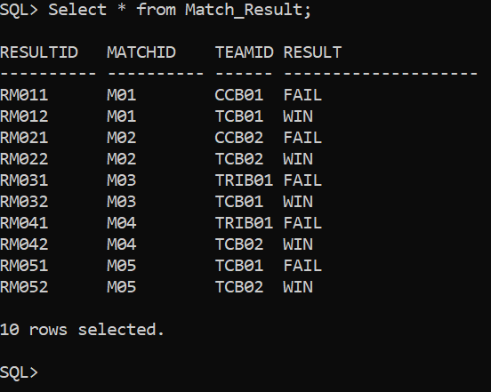

1. **To create a view that displays the details of players along with their team details.**

SQL>CREATE OR REPLACE VIEW Player_Team_View AS SELECT p.PlayerID, p.FName AS FirstName, p.PlayingRole AS PlayingRole, p.Batting AS BattingStyle, p.Bowling AS BowlingStyle, t.TeamID AS TeamID, t.Name AS TeamName, t.Coach AS Coach, t.Captain AS Captain FROM Player p JOIN Team t ON p.TeamID = t.TeamID;

SQL> Select * from Player_Team_View;

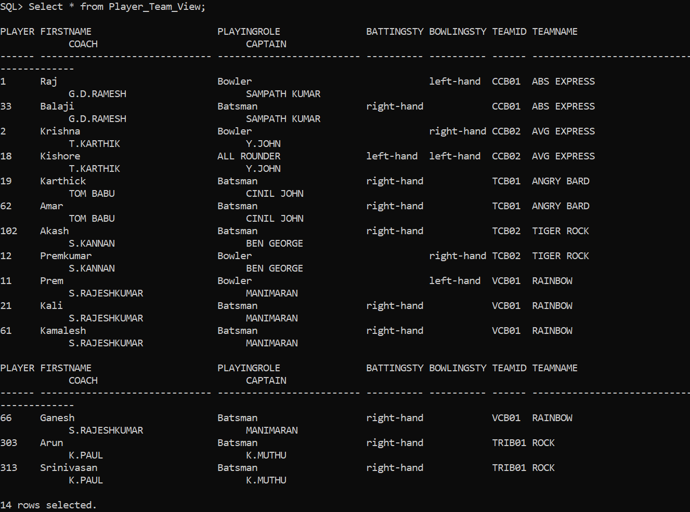

1. **To write a non-recursive PL/SQL procedure to retrieve even-numbered PlayerIDs registered for any Matchwith exception handling.**

CREATE OR REPLACE PROCEDURE Get_Even_PlayerIDs_For_Matches IS

CURSOR even_players IS

SELECT DISTINCT p.PlayerID, p.FName, p.LName, m.MatchID

FROM Player p

JOIN Team t ON p.TeamID = t.TeamID

JOIN Match m ON (m.TeamID1 = t.TeamID OR m.TeamID2 = t.TeamID)

WHERE MOD(TO_NUMBER(REGEXP_SUBSTR(p.PlayerID, '\d+$')), 2) = 0;

v_countNUMBER := 0;

BEGIN

DBMS_OUTPUT.PUT_LINE('Even-numbered PlayerIDs registered for Matches:');

FOR rec IN even_players LOOP

v_count := v_count + 1;

DBMS_OUTPUT.PUT_LINE('MatchID: ' || rec.MatchID ||

' | PlayerID: ' || rec.PlayerID ||

' | Name: ' || rec.FName || ' ' || rec.LName);

END LOOP;

-- Handle case where no records found

IF v_count = 0 THEN

RAISE NO_DATA_FOUND;

END IF;

EXCEPTION

WHEN NO_DATA_FOUND THEN

DBMS_OUTPUT.PUT_LINE('No even-numbered PlayerIDs found for any match.');

WHEN OTHERS THEN

DBMS_OUTPUT.PUT_LINE('Error: ' || SQLERRM);

END;

/

SQL> set serveroutput on

SQL> /

Procedure created.

SQL>SET SERVEROUTPUT ON;

SQL>EXEC Get_Even_PlayerIDs_For_Matches;

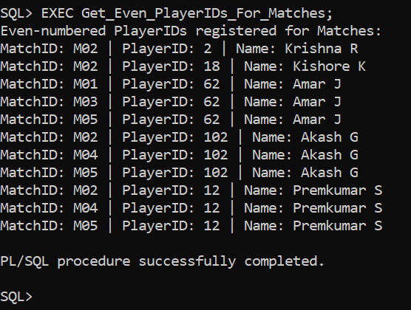

**Result:**

Thus the Triggers,Views andExceptions experiment was successfully completed results are verified.